Aws cli

**List s3 buckets:-**

Command :- aws s3 ls --profile 011821064023_mnd-l3-support-role --no-verify-ssl > ls.json

Here we are taking the output to a json file for using the data many times as it has many buckets each time to take bucket name and get other details

We can use this file as bin

aws s3 ls s3://011821064023-power-predix-east-2-w2-tf-state --profile 011821064023_mnd-l3-support-role --no-verify-ssl --recursive --human-readable -- summarize

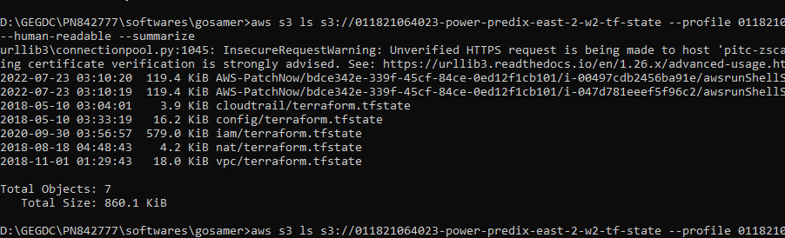

Lifecycle policy

aws s3api get-bucket-lifecycle --bucket 011821064023-predix-io-unmanaged-tf-state --profile 011821064023_mnd-l3-support-role --no-verify-ssl

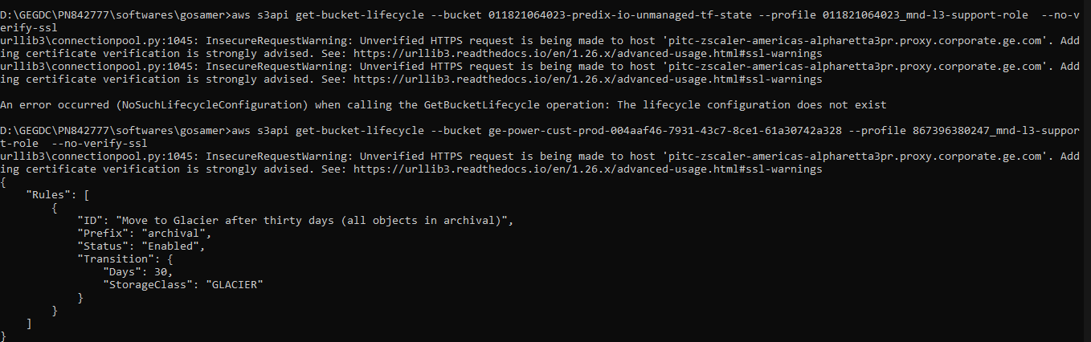

Now to get any bucjet detail such as lifecycle policy and

**Aws s3api** is used to get the bucket details

Aws s3api help gives you the commands

